**IDEATION PHASE**

**Define the problem statements**

|  |  |
| --- | --- |
| **Date** | 19 September 2022 |
| **Team ID** | PNT2022TMID33042 |
| **Project Name** | IOT Smart Farmer |
| **Maximum Mark** | 2 marks |

**Farmer problem Statement Template:**

* create a problem statement to understand our farmer point of view.
* Farmer problem statement template helps you focus on what matter to cultivate better crops.
* Farmer problem statement allows you and your team to find solution for the issues or problems facing in agriculture. throughout the process you will able to cultivate good crops. this problem statement give idea for better farming**.**

**Problem Statement templates:**

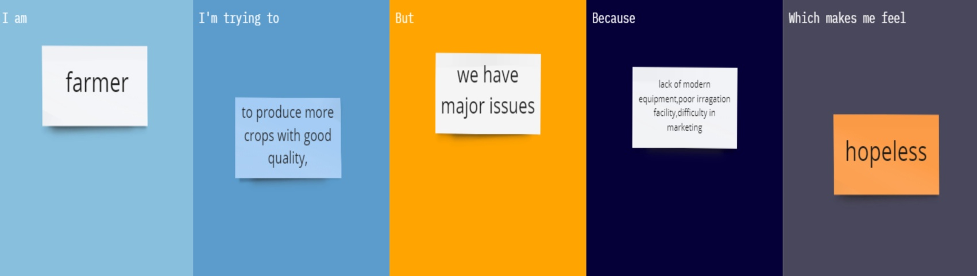

|  |  |  |  |  |  |
| --- | --- | --- | --- | --- | --- |
| **Problem**  **Statement**  **(PS)** | **I am** | **I’m trying** | **But** | **Because** | **Which make me** |
| PS-1 | A Farmer | To produce more crops with good quality. | we have major issues | Lack of modern equipment,poor  Irrigation facility,difficulty  In marketing. | hopeless |